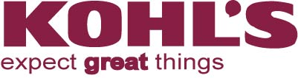
KOHL’S Supplementary Form For Testing
Bill of Materials (B.O.M) - Generic

Product Description: _________________________________________________________

Style Number(s): ____________________________________________________________
Note:
- Bill of materials (B.O.M) must accompany every product being sent for testing.
- Lead content in all materials & components will be tested in accordance to the below B.O.M and finished product submitted
- In case common material/component is used on more than 1 style, vendor needs to mark for group testing in the B.O.M. of TRF CLEARLY for traceability purpose.
 | Material  (Fabric / Leather / Plastic / Paper / Metal etc ) |  | Is PVC  or other soft plastic, vinyl, or synthetic leather used? | Color |  | Shared Style Number | Preferred Suppliers  (If yes, please indicate the name)
1
1
2
3
4
5
6
7
8
9
10
11
12
13
14
15
16
17
18
19
20

Name: __________________________________________________ Date: ______________________

Company Name: _________________________________________________
We certify that the above information is correct to the best of our knowledge and that we have submitted all materials for testing.

